**Lab 10 – Create VPC (Auto generate project)**

**1.Created VPC.**

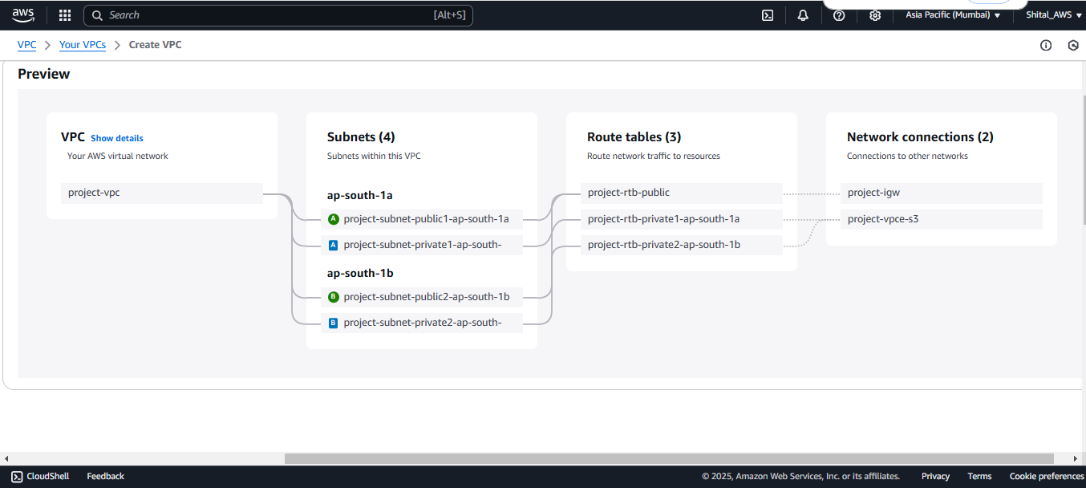

**2.Successfully Created VPC and more with Auto generate project.**

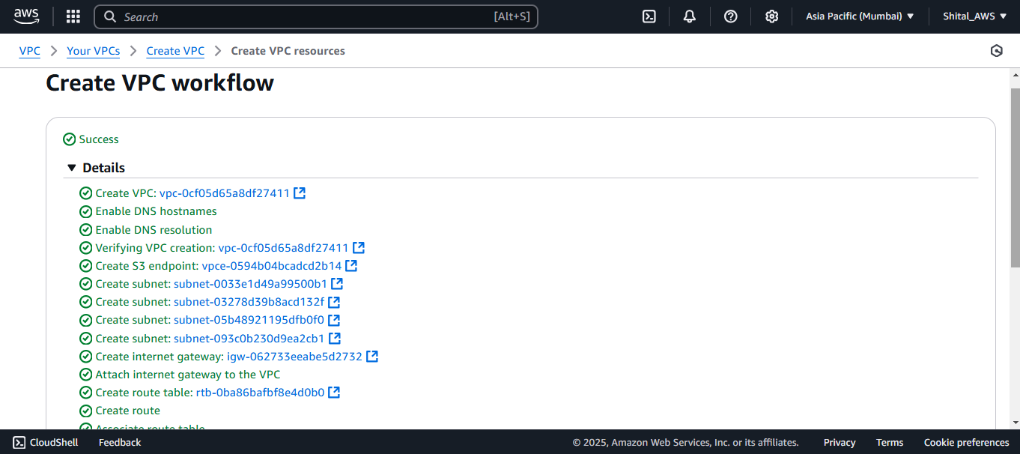

**3.Created VPC.**

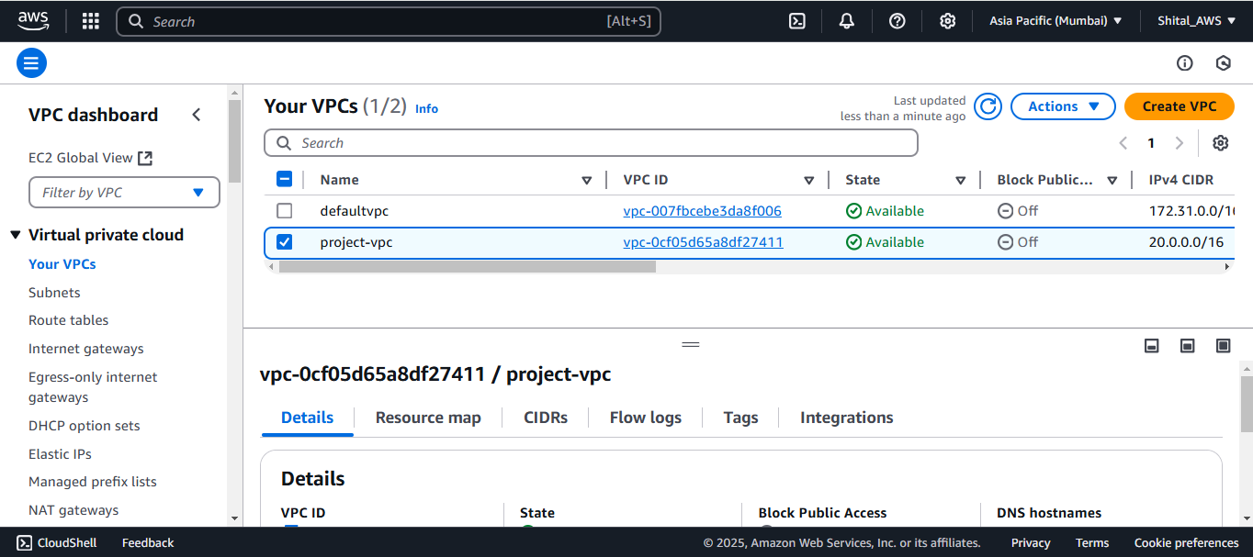

**4.Created Public and Private Subnets .**

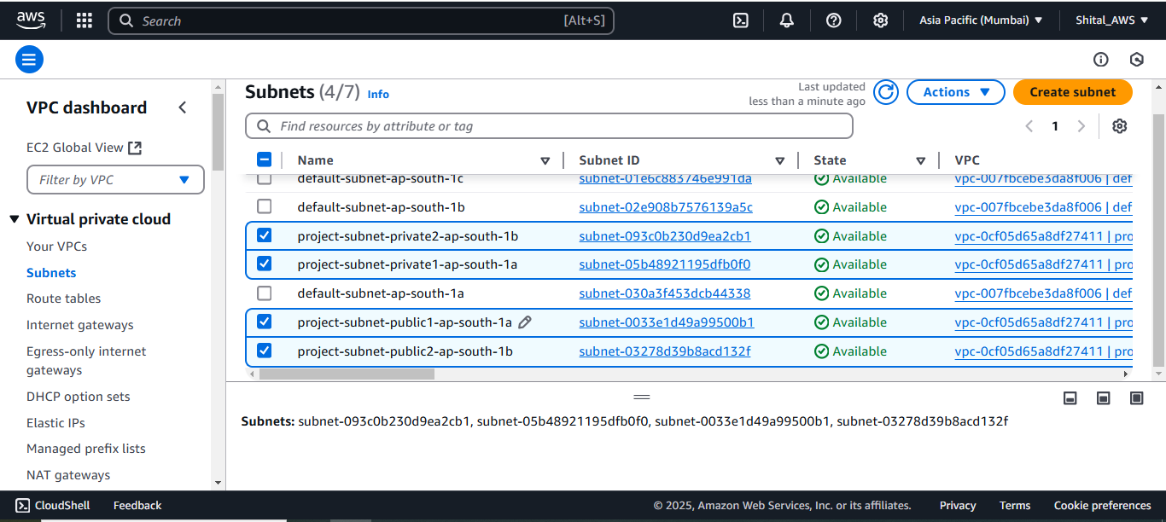

**5.Created Public and Private Route Tables and associated with subnets.**

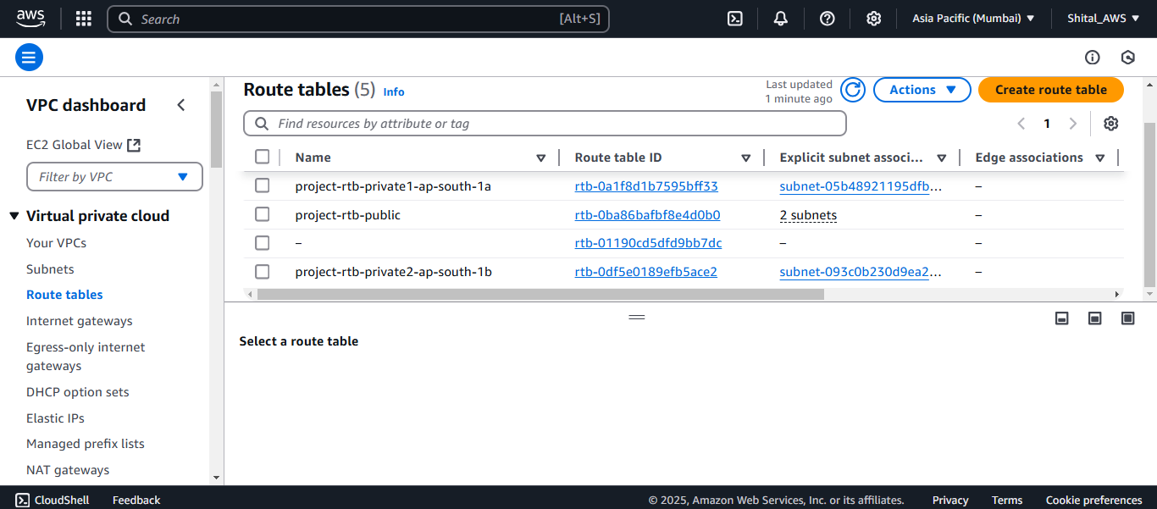

**6.Created Internet gateway and attached to VPC.**

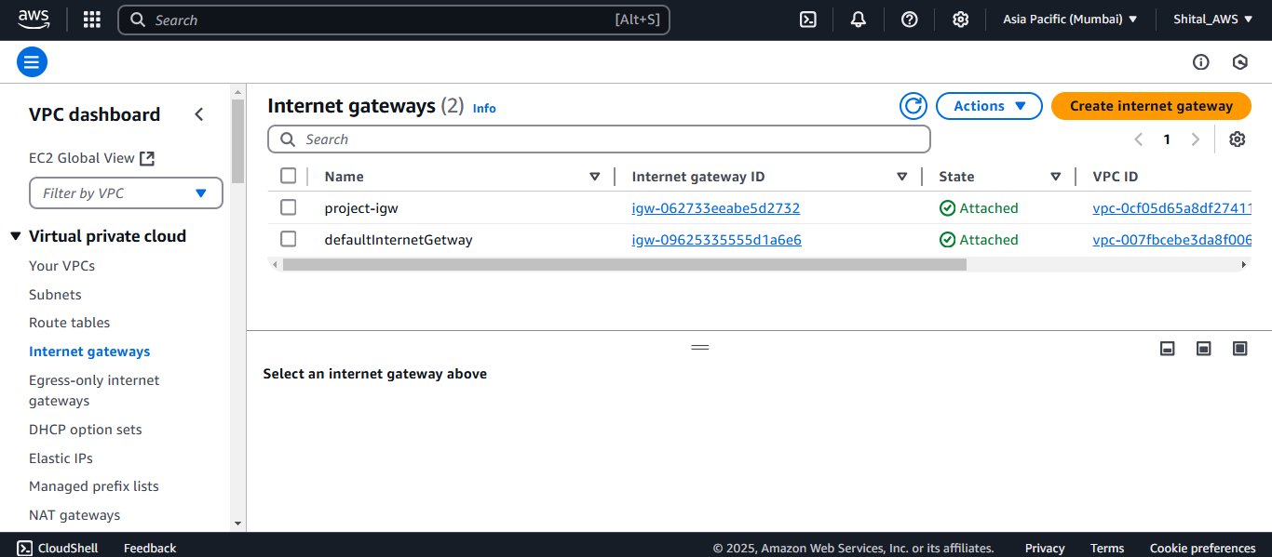

**7.Allocated Elastic IP.**

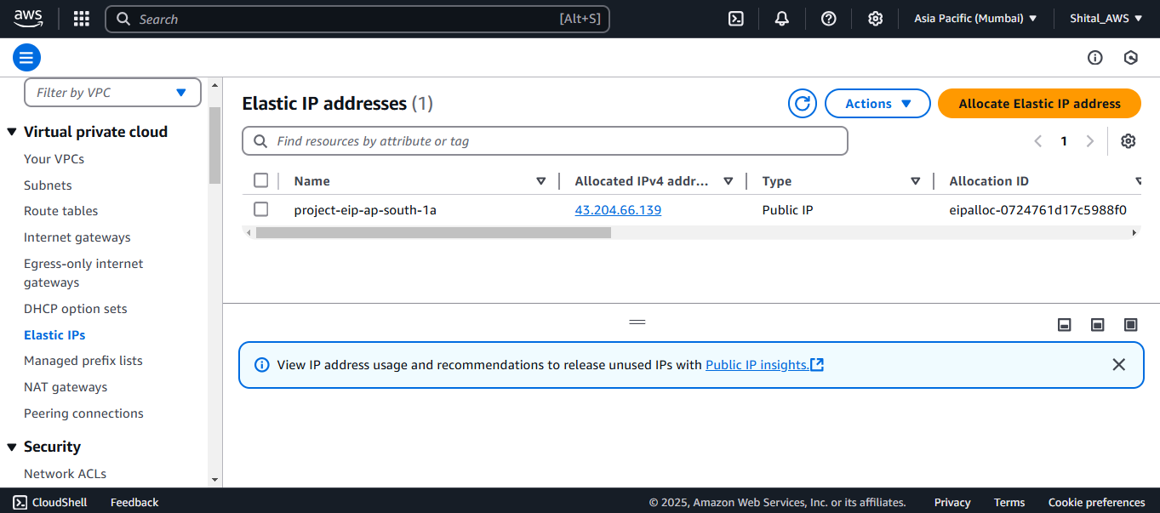

**8.Created NAT Gateway.**

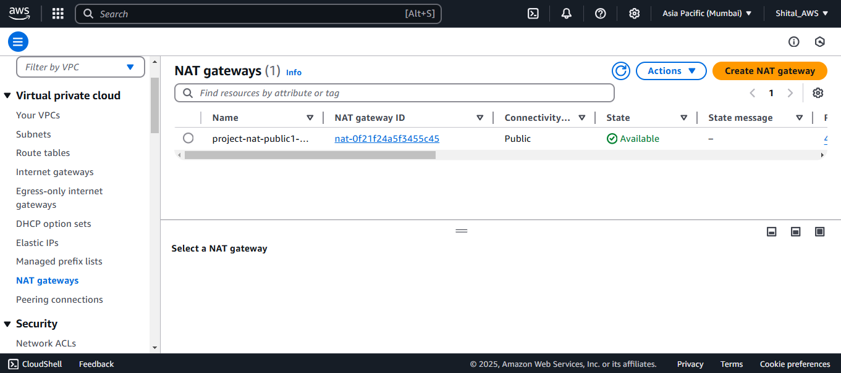

**9.Created NACL .**

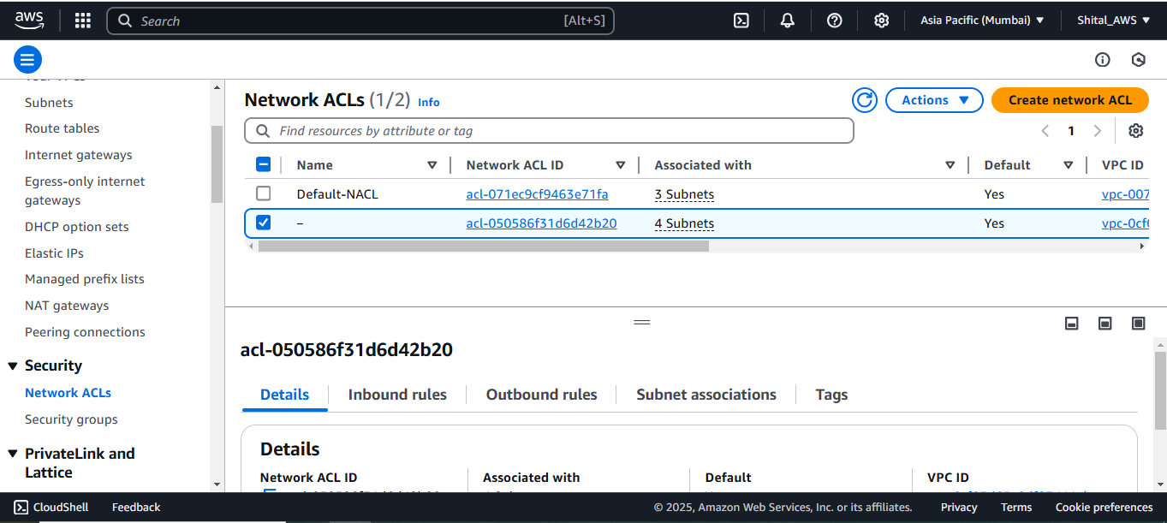

**10.Created Security Group .**

